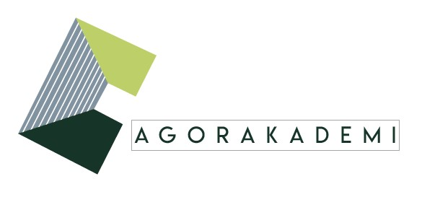

INTERNATIONAL SEMINAR

PUBLIC EXPERIENCES AND AESTHETIC FORMS

September 23, 2022
9:30 a.m. – 6:00 p.m.
Columbia Global Centers | Paris
Reid Hall - Salle de Conférence
4 rue de Chevreuse 75006 Paris

Abstracts

Nilüfer Göle (Sociology, Ecole des Hautes Etudes en Sciences Sociales): Public encounters and Creative accommodations
During the last four decades, we witnessed a series of public controversies around Islamic presence in European countries. Since 1989, the year when the headscarf debate in France and the fatwa against Salman Rushdie began, Europe had to deal with accomodating Islam. In my presentation, I’ll focus on two distinct performative practices in public to highlight the ways in which creative accomodations can emerge from the religious-secular divide. The first case concerns the constitution of a human chain by Muslim citizens around the synagogue in Oslo in 2015. The second case of performative action concerns the public fast breaking meal (iftar) that gathered together pious and secular people alike during the Gezi Protest movements in Istanbul in 2013.

Juliane Vogel (German Literary Studies, University of Konstanz) : The Human Chain as Social and Aesthetic Form
In my presentation I will discuss materials concerning the protest form of the human chain which has been traveling through Europe since the early eighties. Starting in Berkshire (Great Britain) it was adopted by the German campaign for Nuclear disarmament and later on by the Baltic independence movements (“Baltic way”) where it has been present ever since as a public symbol of unity and autonomy directed against Soviet and Russian occupation. I will argue that the persuasive power of human chains is not only rooted in the strength of this form’s symbolism, but also and perhaps mainly in its performative qualities. Chains are enacted and by enactment constitute a sociality which escapes vertical power impositions and takes the stage in horizontal moves. Requiring meticulous organization, it still has a high degree of flexibility and plasticity: qualities which help us understand that successful forms are always dynamic and evolve in time. In our workshop I will present first thoughts on the process by which a human chain is made, and on its transformations as it travels.
Thomas G. Kirsch (Anthropology, University of Konstanz): Protest Etiquette
In the workshop, I will present some preliminary findings and analytical thoughts on “protest etiquette”, that is, the advice given to participants of protests in public space on how to behave in the course of these events: how they should prepare for the occasion; how to move and present themselves in public space; what inner attitudes to adopt (and how to maintain them if things are getting hot); how to interact with (alleged) allies and (alleged) opponents. I argue, first, that “protest etiquettes” are aesthetic-cum-social forms that travel not only transnationally but also between highly diverse types of protest events and social contexts. For instance, members of the animal rights organization PETA, who are advising people on how to enact protest events in PETA’s name, instruct participants to adopt “professional” conduct; for instance, to avoid flashy fashion accessories and to wear business-like attire. Second, recent protest etiquette advice given to Whites intending to join Black Lives Matter events in the USA is a fascinating example of which forms are supposed not to travel in public space due to the controversies around ‘cultural appropriation’.
Daniel Gamper (Philosophy, Universitat Autònoma de Barcelona) What does accommodation of cultural and religious differences mean?

Following the well-known rapport of the Bouchard-Taylor Commission in Quebec, I propose a threefold definition of accommodation to answer these questions. This definition shows how accommodation (be it reasonable or creative) aims at visibility, adaptation, and hospitality. Accommodation of religious or cultural differences is compatible with different understandings of secularity (laïcité). Static symbols (crucifix, cross) are one of the contested fields of accommodation. The aesthetic, didactic, and political meaning of these symbols is often the object of public controversies that can eventually be pacified with the use of reasonable and creative accommodation.

Philipp Ekardt (Art and Literary Studies, University of Konstanz): Forms in Translation. Contemporary Art and Post-Socialist Spaces
My presentation develops directly from our discussions during the previous AgorAkademi/Traveling Forms-seminar earlier this year: One of the questions we raised concerned the extent to which – in the realm of contemporary art – spaces which are nowadays referred to as ‘post-socialist’ (such as the former German Democratic Republic, but also the former Soviet Union) have been figured as domains of cultural diversity. I will focus on examples of contemporary art that reject the myth of Socialism’s universality and homogeneity, foregrounding concepts of mobile, traveling forms instead. These artistic practices engage in the task of translation and highlight historically Socialist territories as zones of intercultural exchange.
Sarah Dornhof (Anthropology, Humboldt University Berlin) Creating Translational Spaces through Art and Collective Practice
My contribution builds on impressions of the documenta 15 in Kassel, focusing on discussions with participating members of the Moroccan art space Le18 and including observations of public programs by Le18, Atis Rezistans / Ghetto Biennale, and Archives des luttes des femmes en Algérie. My question is whether we can translate the curatorial concept of lumbung into translational spaces, and how participants’ and my own interpretations of collective art practices connect to these concepts. What kind of potentials, frictions and manifest misunderstandings have been opened by the current documenta and what can we learn from Kassel in relation to translation, space, art, and collective practice?
Jeannine-Madeleine Fischer (Anthropology, University of Konstanz): Transient Forms of Visual Activism in Urban South Africa
In my presentation I will discuss forms of visual activism that are characterized by impermanence. Their emphatically volatile presence contributes to an ever-changing visual patchwork in public space. In these cases, transience facilitates a particular up-to-date-ness and enables activists to respond to topical sociopolitical challenges. While multiple layers of visual interventions overlap and replace one another, there are also “stabilized“ forms that keep recurring; these circulate translocally. Partly traveling as ‘silhouettes’, they are flexible enough to react to current concerns without losing their recognizability. I conceive of these public visual articulations as hybrid forms which combine aesthetic and political elements in public space and come with particular tensions and frictions, sometimes even contradictions: ‘tuning’ into the environment vs. the intention to disrupt; encryption vs. clarity of messaging; ephemerality vs. secondary representations. I will tentatively explore the dynamics of these transient forms as creative accommodations which harness the specific temporalities of the urban visual patchwork.
Nadia Fadil (Anthropology, University of Leuven) Affective solidarities: the case of ‘le choeur de Ali Aarrass'
This paper inquiries into the possibilities of solidarity with people accused of terrorism. It builds upon an ethnographic fieldwork with activists and artists in Belgium, who set up a theater project around Ali Aarrass, a Belgian-Moroccan, who faced a jail sentence of 12 years on accusations of complicity with terrorism-related activities. First arrested in Spain in 2008, but acquitted soon after, his eventual deportation to Morocco, torture and fraught conviction will be continuously challenged by a solidarity committee that was set up in 2010. Ever since, this group has demanded his release and condemned his illegal extradition to Morocco and Belgium’s passivity on this case through various type of political actions. The theater project emerged in the continuation of the different actions of the committee, but in a tedious political context wherein direct political actions became more difficult to sustain due to the terrorist attacks of 13 November 2015 in Paris. My analysis of ‘le choeur de Ali Aarrass’ seeks to examine this transition of the political actions into a theatrical form, by attending in particular to the way in which the involved actors participated in and reflect on this experience. Building on the work of Massumi (1995) and Ahmed (2004), I will suggest that ‘le choeur’ was organized around what I will describe as an affective intersubjective commitment structured around the figure of Ali and his sister (who was also a member of the group), rather than an abstract ideological commitment to a particular cause. This personalization of Ali and his family, which was in part made possible through various cultural interventions, has allowed for a new sensibility (Rancière) around his case. I will also reflect on the implication of these observations on the broader question of solidarity and intersubjectivity (and the possibility thereof) in relationship to people accused of terrorism.

Short bios

Nilüfer Göle is a NOMIS board member and Professor of Sociology at the Ecole des Hautes Etudes en Sciences Sociales (EHESS) in Paris. Her sociological approach aims to open up a new reading of modernity from a non-western perspective and engages a broader critique of Eurocentrism. She works on Islamic visibility, secularism and intercultural controversies in European public spheres (ERC research project EuroPublicIslam (2008-2013)). Currently she revisits the notion of Public space in different cultural sites to inquire about emerging forms of social agency, collectivity and creative expressivity. In her Nomis project on Public Space Democracy (2016-2020), she studies Maidan protest movements and citizenship in the global age. Her new Nomis AgorAkademi project (2020-2025) is conceived as an assembly of researchers from social sciences, humanities and art to explore the emancipatory potential in Public space making. Nilüfer Göle is the author of many publications translated in different languages as The Forbidden Modern: Civilization and Veiling (University of Michigan Press, 1996), Islam in Europe: The Lure of Fundamentalism and the Allure of Cosmopolitanism (Princeton, 2011), Islam and Secularity: The Future of Europe’s Public Sphere (Duke University Press, 2015) and The Daily Lives of Muslims. Islam and Public Confrontation in Contemporary Europe (Zed Books, 2017). Most recently, she edited Public Space Democracy : Performative, Visual, Normative Dimensions of Politics in a Global Age (Routledge, 2022) and co-author with Nilüfer Göle, Richard Rechtman, Sandra Laugier et Yves Cohen, Revendiquer l’espace public (CNRS Editions, 2022).

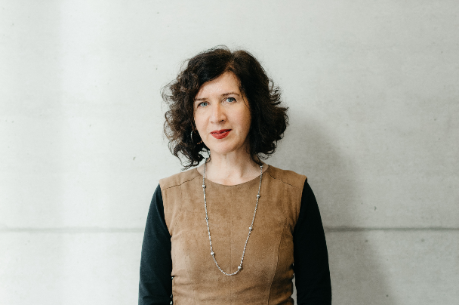Juliane Vogel is professor of modern German literature and general literary studies at the University of Konstanz (Germany). She is leading the Nomis Traveling Forms project. Between 2013 and 2019, she was a board member of the Konstanz-based Cluster of Excellence “Cultural Foundations of Social Integration,” and in 2018 she was a fellow in the DFG-funded Humanities Center for Advanced Studies “Evidence of Images: History and Aesthetics” at Freie Universität Berlin. Between 2018 and 2019, she performed research as a fellow at the Wissenschaftskolleg (Institute for Advanced Study) in Berlin. Vogel received the Leibniz Prize in 2020 for work that sets new standards, historically and systematically, in literary and theater studies with international resonance, hermeneutically oriented and inspired by cultural studies. Through her numerous books and essays, particularly on German and Austrian literature of the 19th and 20th centuries, Vogel has transcended boundaries in theoretical and methodological orientation, cultural history and literary history domains, and disciplinary definitions.
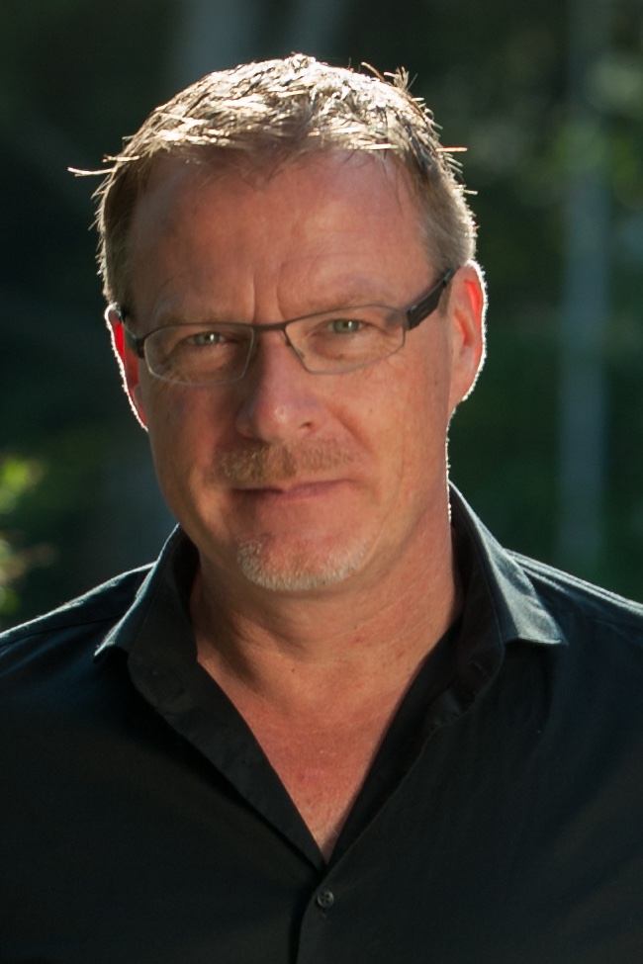Thomas G. Kirsch is professor of Social and Cultural Anthropology at the University of Konstanz. He has published two books on African Christianity in Zambia, one of them entitled "Spirits and Letters: Reading, Writing and Charisma in African Christianity" (Oxford, 2008), as well as articles in some of the major refereed journals for anthropology (e.g., Africa; American Anthropologist; American Ethnologist). He has also co-edited "Domesticating Vigilantism in Africa" (Oxford, 2010, together with Tilo Grätz) and "Regimes of Ignorance: Anthropological Perspectives on the Production and Reproduction of Non-Knowledge" (Oxford, 2015, together with Roy Dilley).
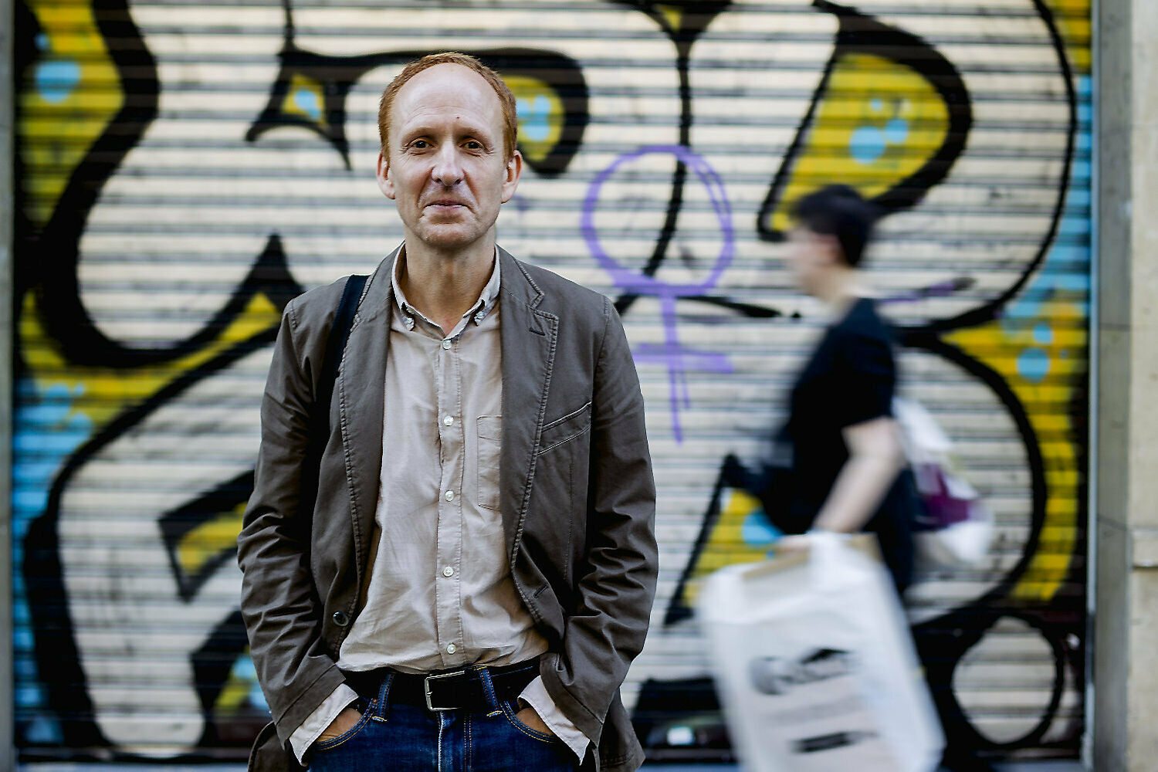Daniel Gamper is Assistant Professor at Philosophy Department in Universitat Autònoma de Barcelona. Research on political philosophy, specifically religion, democracy, and free speech. Author of “Laicidad europea. Apuntes de filosofía política postsecular” (Bellaterra, 2016), “Las mejores palabras. De la libre expresión” (Anagrama, 2019). He is editor of “La fe en la ciudad secular” (Trotta, 2014), and together with Camil Ungureanu, “Jürgen Habermas” (Katz, 2019). He writes op-eds for the Catalan newspaper Ara.

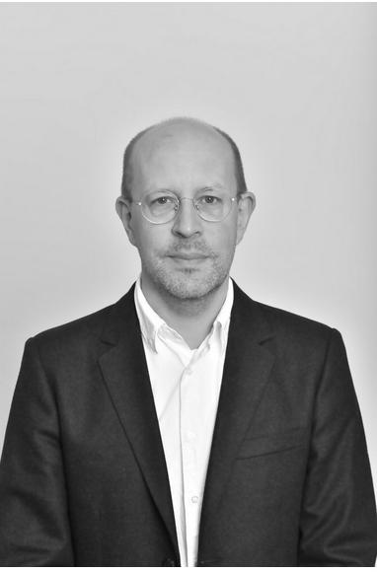Philipp Ekardt is the academic coordinator for the NOMIS-Project ‘Traveling Forms’ at the University of Konstanz/Germany. Previously he was a visiting professor at the Institute for Art History and Aesthetics at the University of the Arts/Berlin and has held positions at the Warbug Institute (London), where he was a member of the international research group ‘Bilderfahrzeuge – Aby Warburg’s Legacy and the Future of Iconology’, and at the Free University/Berlin, as well as teaching and advising theses in smaller capacities at University College London’s Department of Classics, at the Bard Center for Curatorial Studies/New York, and the University of the Arts/Zurich. He was a NOMIS-fellow at the eikones Center for the Theory and History of the Image at Basel University and has held fellowships at the Cinepoetics Center for Advanced Film Studies (Free University Berlin) and at the Centre Allemand d’Histoire de l’Art/Paris. He studied art history and comparative literature in Berlin, Paris and New Haven, receiving his PhD from Yale University.
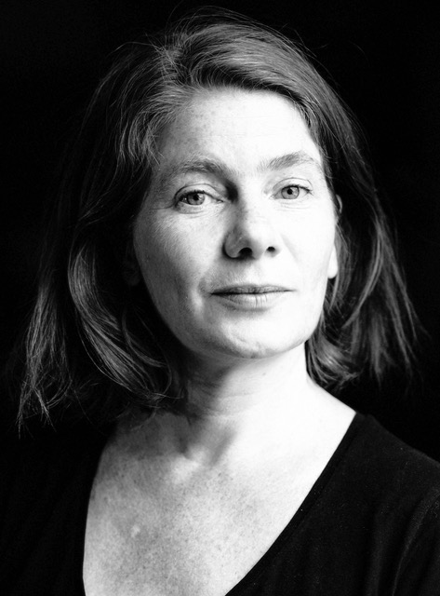Sarah Dornhof is a postdoctoral researcher at the Humboldt University Berlin. She received her PhD in Cultural Studies & Anthropology from the European University Viadrina in Frankfurt/Oder. Her current research examines contemporary art and cultural politics in Morocco in relation to questions of memory, heritage, and archives. Among her publications are Alternierende Blicke auf Islam und Europa: Verletzung als Rationalität visueller Politik (Fink, 2016); F(r)ictions of Art (co-edited, Paragrana 25/2, 2016), Situating Global Art. Topologies – Temporalities – Trajectories (co-edited, transcript, 2018), Contested Urban Spaces: Monuments, Traces, and Decentered Memories (co-edited, Palgrave 2022).
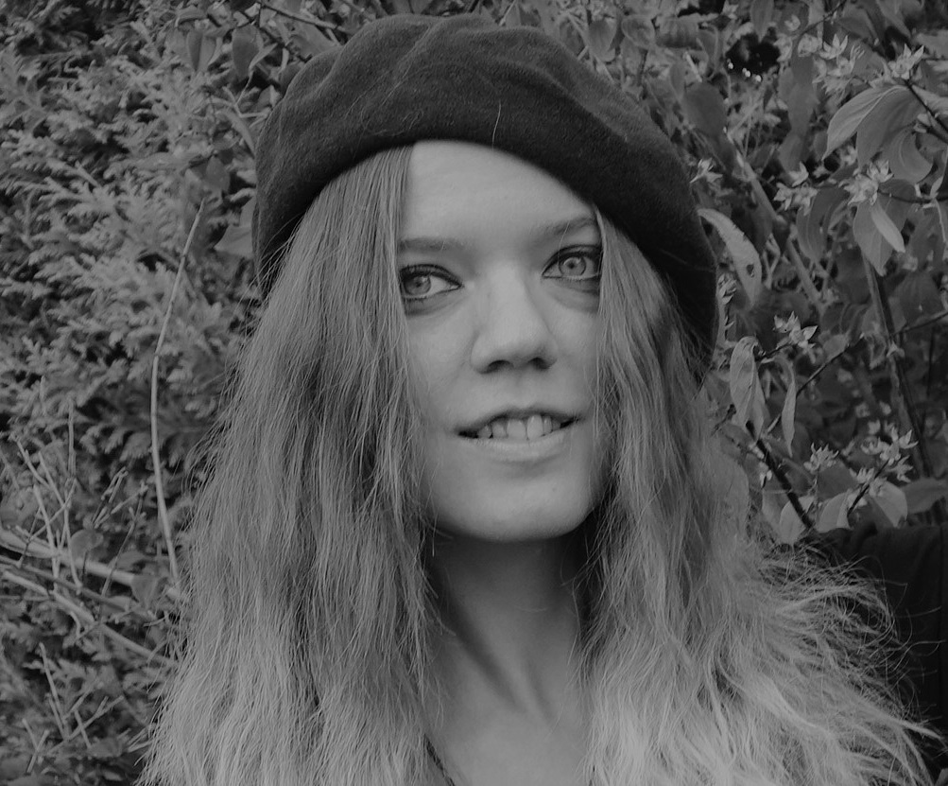Jeannine-Madeleine Fischer holds a phD in cultural anthropology from the Ludwig-Maximilian- University of Munich where she was part of the DFG-funded, interdisciplinary research group „Urban Ethics“. In her thesis on perceptions of pollution and environmental ethics in Aotearoa New Zealand, she examined environmental projects as practice-oriented fields of ethical negotiation in the city. For this project, she conducted multi-phased field research in Auckland for a total of 11 months. Since October 2020 she is a postdoctoral researcher in the NOMIS-funded research group „Traveling Forms“ at the university of Konstanz. Her project explores activism as a mobile aesthetic form in urban South Africa. Her research interests include human-environment-relationships, activism, aesthetics and creativity as well as urban and psychological anthropology.
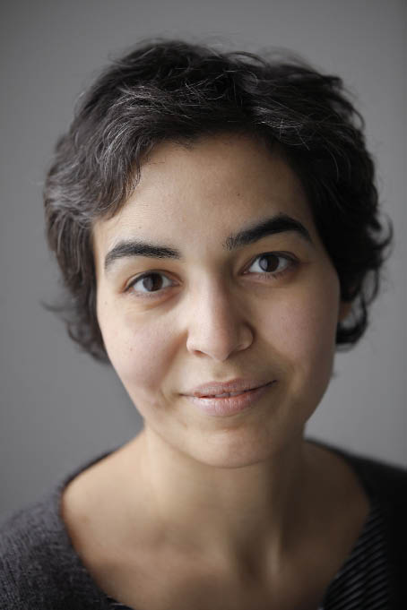Nadia Fadil works as an Associate Professor at the IMMRC (Interculturalism, Migration and Minorities Research Centre) at the University of Leuven. Her work centers on Islam in Europe (taking Brussels as ethnographic site), both as a lived tradition as well as an object of regulation. Her most recent publications include Secular Bodies, Affects and Emotions. European configurations (with Monique Scheer and Birgitte Scheplern Johansen, Bloomsbury 2019) and Radicalization in Belgium and the Netherlands. Critical perspectives on Violence and Security (with Martijn de Koning and Francesco Ragazzi, IB Tauris 2019).
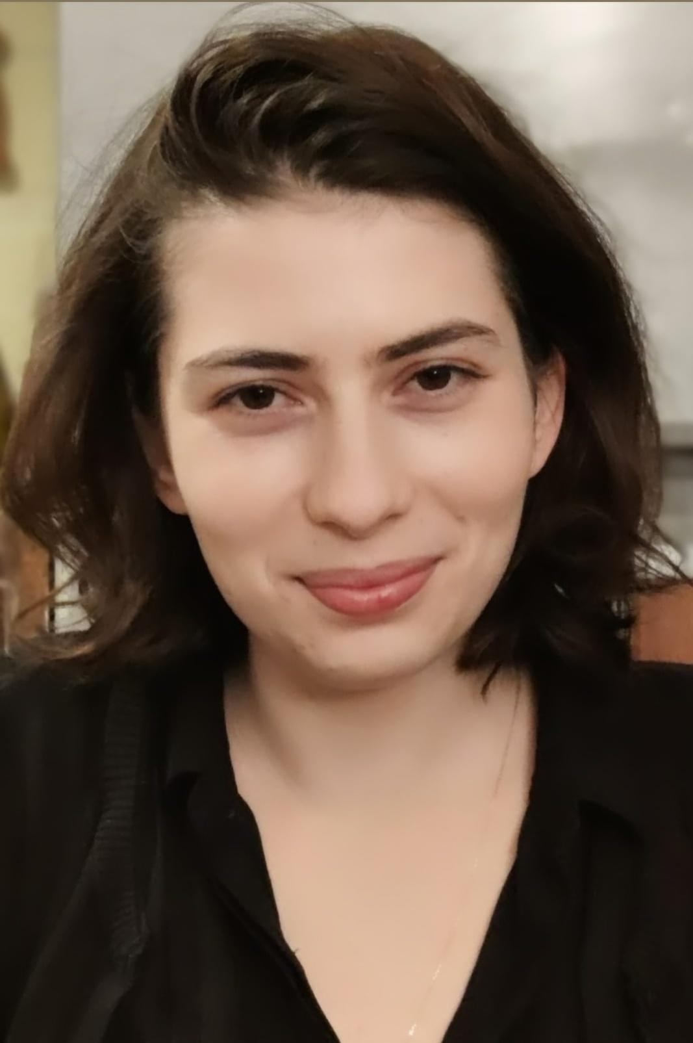Gökçe Tuncel is a PhD student at École des Hautes Études en Sciences Sociales (EHESS) in Paris. She holds an MA degree on Alternative Media Studies and Collective Action from the University of Paris 8. She studies social movements, public sphere, alternative medias and political agency. She worked three years as research assistant in the Public Space Democracy research project directed by Nilüfer Göle. She co-authored the book Mobilisations numériques: Politiques du conflit et technologies médiatiques and published an article on the politization process of the ultras in the Gezi movement. She is currently teaching political science at EHESS.
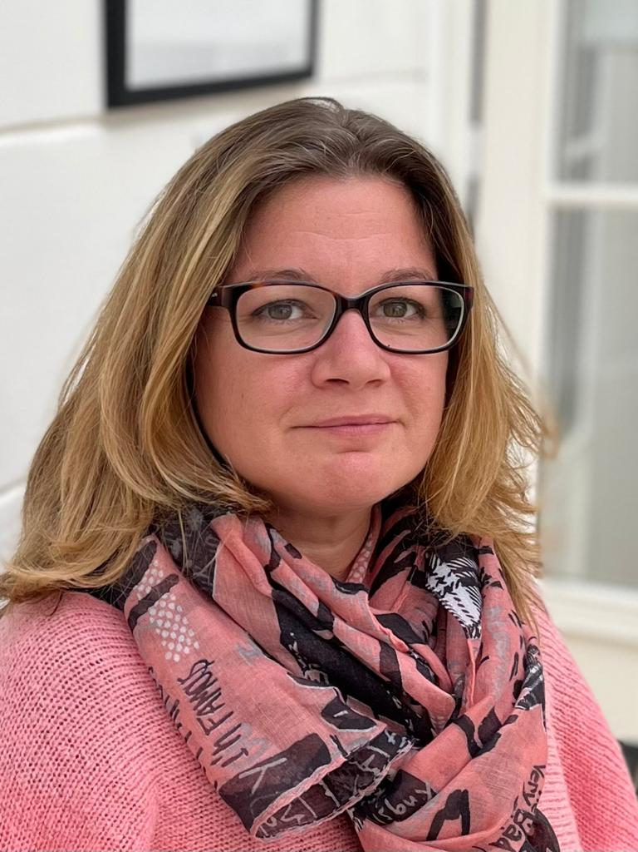Bochra Kammarti obtained her PhD degree in sociology from the EHESS in December 2019 with a comparative study of the social genesis of Islamic finance in France, Germany and the United Kingdom. From 2010 to 2012 she integrated the research team of the ERC program EuroPublicIslam directed by Nilüfer Göle (Cespra EHESS) on the contemporary controversies around Islam in Europe and in 2020 she obtaiend a postdoctoral position in the ERC Tarica on the political, social and institutionnal changes in North Africa after 2011 directed by Alia Gana (Ladyss CNRS). She is recently laureate of the BCC program “Islam, Religion and Society” 2020 which studies in France the conflicts related to the practice of Islamic prescriptions in the professional field and how Muslims express their multiple belongings through their professional activities. She is currently postdoctoral researcher in the Nomis project AgorAkademi directed by Nilüfer Göle.

